AI STUDY BUDDY API

An AI-Powered Learning Support System

TEAM MENBERS :
1.TEAM LEADER :DHANALAKSHMI.S (CODE EXECUTER)
2.TEAM MEMBER:JASMINE.K (DOCUMENTATION)
3.TEAM MEMBER:KIRUTHIGA.B (PPT & PRESENTATION)
4.TEAM MEMBER:DHANUSHREE.R (VOICE OVER & GITHUB)

- INTRODUCTION
AI Study Buddy API is an AI-powered backend application developed to support students in their learning process. The system provides secure user authentication, study material management, AI-based summarization, and automatic quiz generation.
The application is developed using Node.js and Express.js, with MongoDB used for database management. Gemini AI is integrated to provide intelligent learning features.
- Objectives
The main objectives of the AI Study Buddy API are:

- To provide secure user registration and login.
- To implement authentication and authorization.
- To allow students to upload study materials.
- To generate summaries from study materials using AI.
- To generate quizzes automatically using AI.
- To provide role-based access control.
- To develop secure and reliable REST APIs.

- Technologies Used

Technology | purpose
Node.js | Backend runtime environm
Express.js | REST API development
MongoDB | Database management
JWT | Authentication and authorization
Bcrypt | Password hashing
Gemini AI | AI-based summary and quiz generation
Multer | File upload handling
Postman | API testing
GitHub | Version control

- System Architecture
The system follows a backend-based REST API architecture.
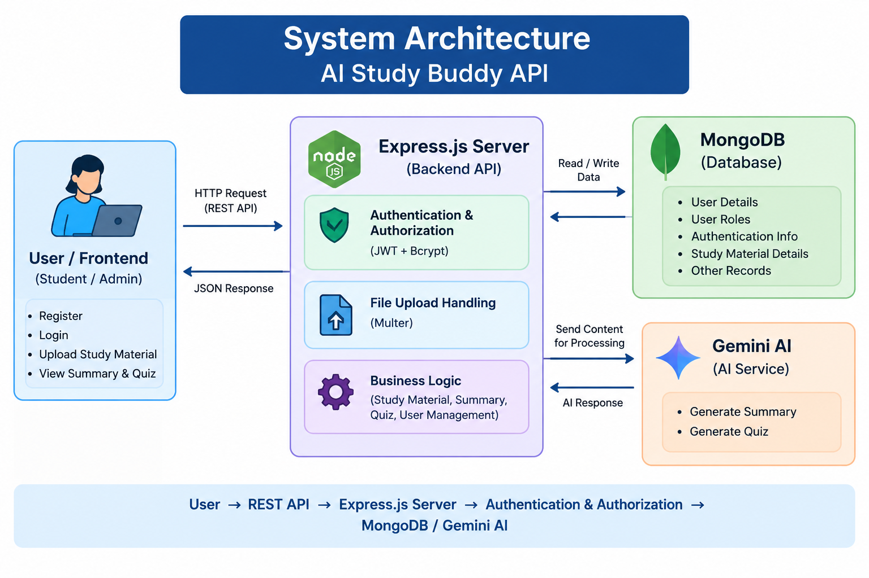
The Express.js server acts as the main communication layer between users, the database, and the AI service.

- User Registration
The registration API allows new users to create an account.
The user provides details such as:
- Name
- Email
- Password
- Role
The password is securely hashed using Bcrypt before being stored in MongoDB.
Result: A new user account is created successfully.

- User Login and Authentication
Registered users can log in using their email and password.
During login:
- The backend receives the login credentials.
- The email is checked in the database.
- The password is verified using the stored hashed password.
- JWT access and refresh tokens are generated.
- The tokens are used to access protected APIs.
This provides secure authentication for the application.

- Role-Based Authorization
- The system supports different user roles such as Student and Admin.
- JWT middleware is used to verify authenticated requests. Protected APIs can be accessed only by authorized users.
- Role-based authorization helps prevent unauthorized access to restricted resources.
8. Study Material Upload
Students can upload their study materials through the API.
Multer is used to handle file uploads. The backend receives the uploaded material and processes the required information for further AI operations.
The uploaded content can be used for:
- Summary generation
- Quiz generation
- Learning and revision

- AI-Based Summarization
- The AI Study Buddy API provides an automatic summarization feature.
- The uploaded study material is processed and relevant content is sent to the Gemini AI service. The AI generates a concise summary containing the important information from the study material.
- This feature helps students understand lengthy learning materials quickly and supports faster revision.
10. AI-Based Quiz Generation
The system can automatically generate quizzes from study materials.
The AI analyzes the provided learning content and generates relevant questions and multiple-choice options.
The quiz feature helps students:
- Test their understanding.
- Practice important concepts.
- Identify areas that require additional study.
- Improve revision effectiveness.

Project Setup
- npm install → required packages install
Start Backend Server
- npm start → server start
Connection
- MongoDB connect
.env
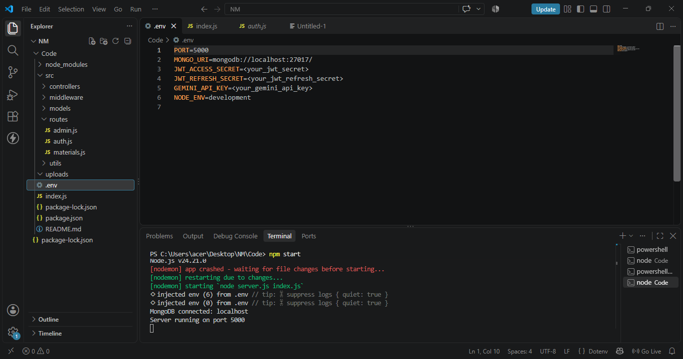

- index.js
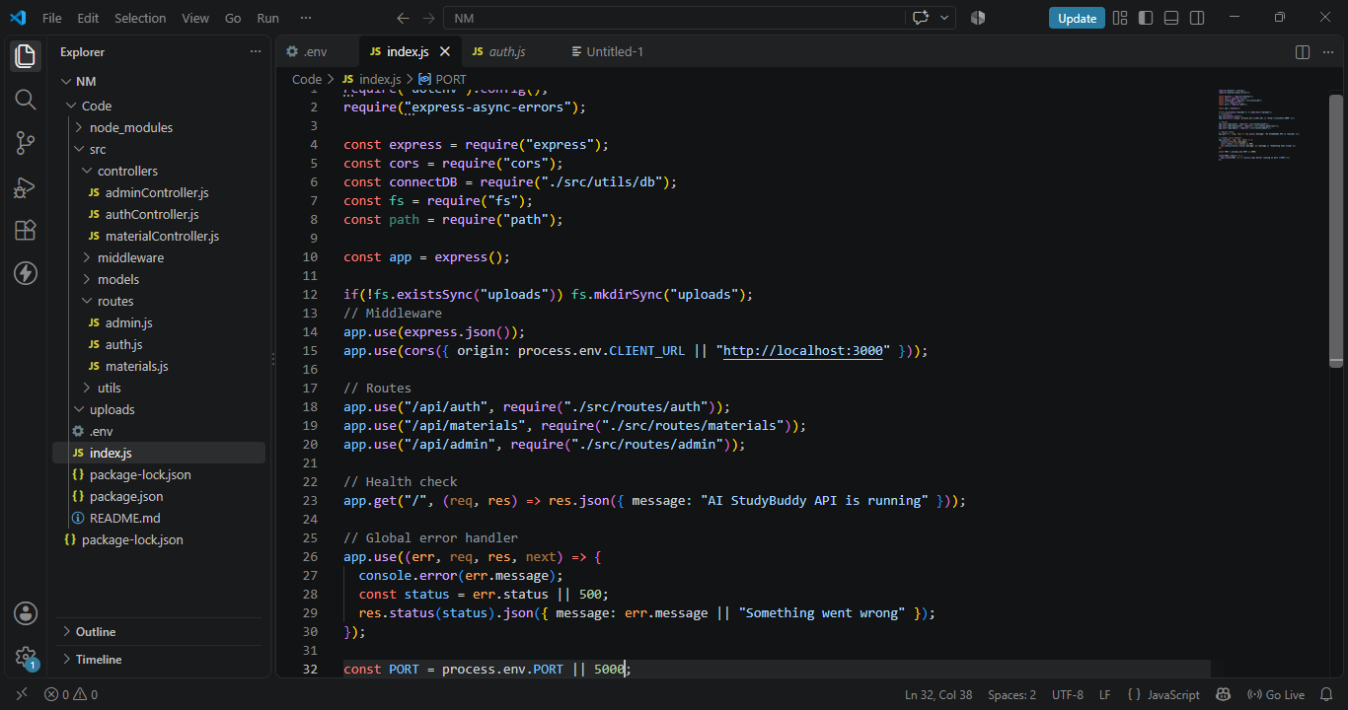
- package-lock-jason
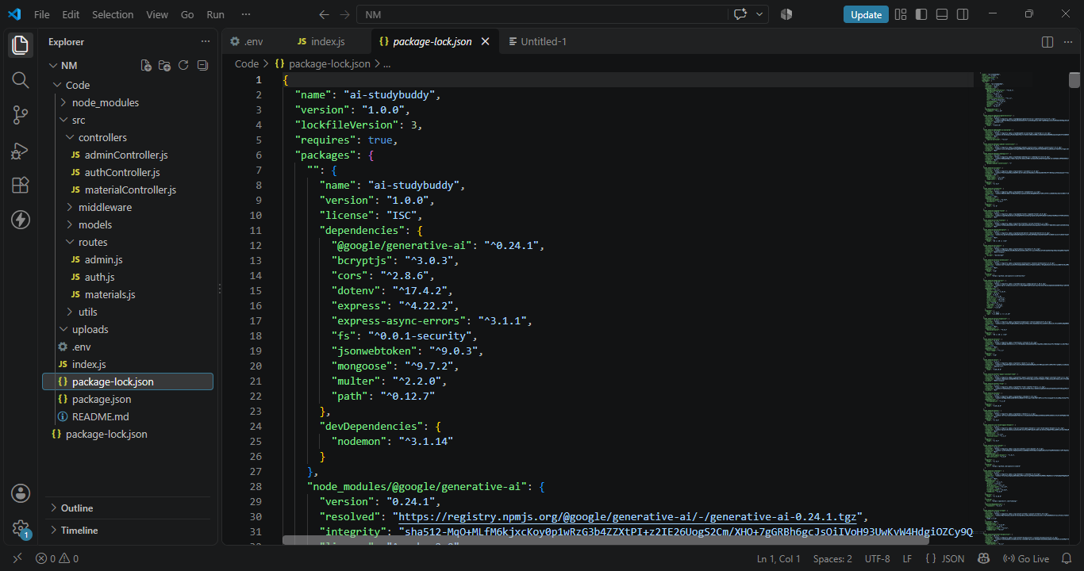

- package-jason
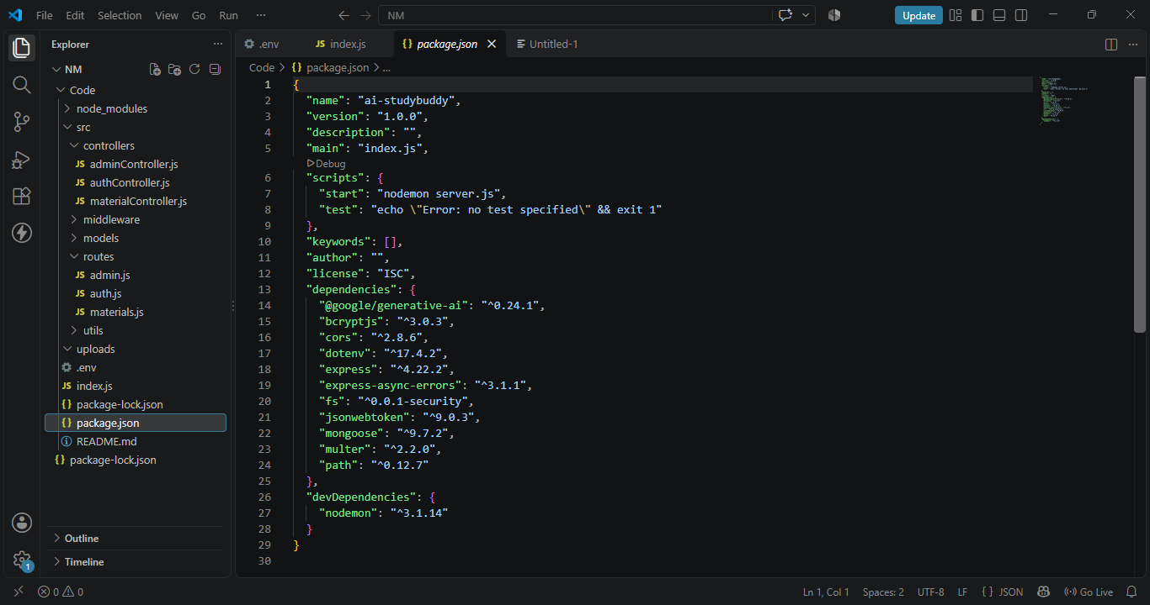
- matials.js
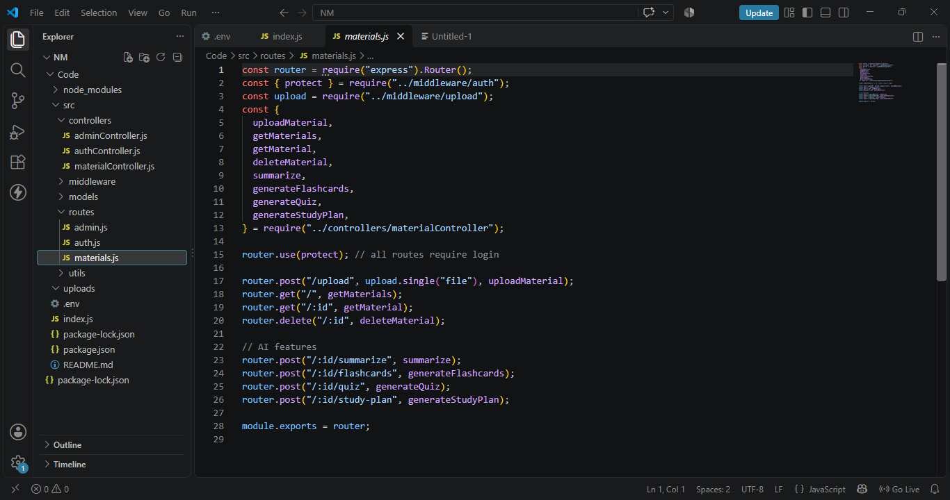

- auth.js
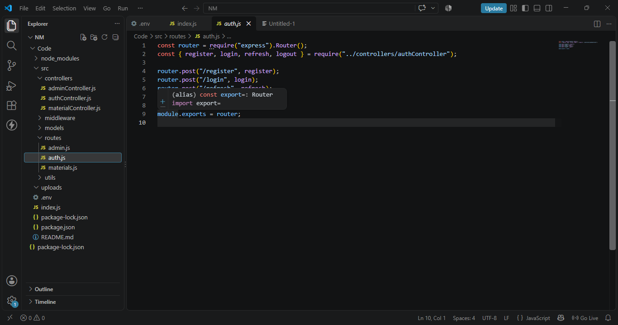

- admin.js
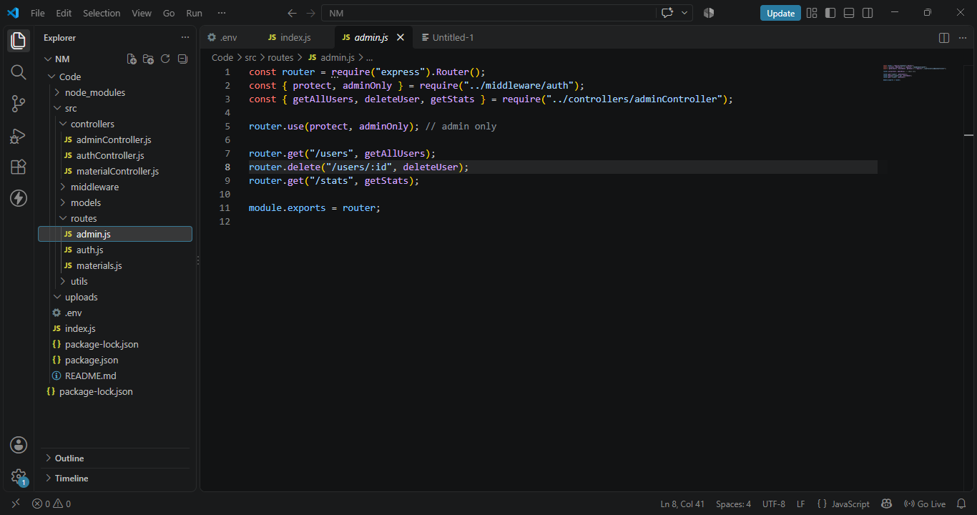

- upload.js
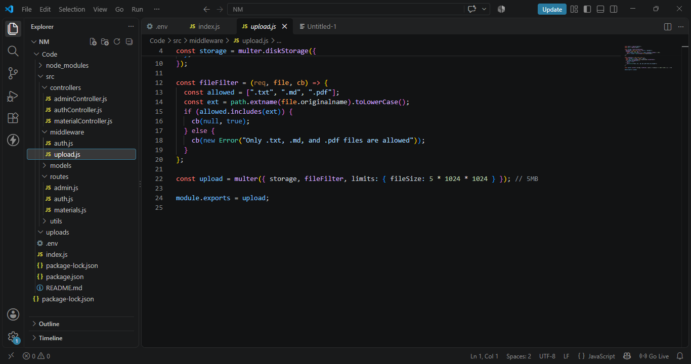

- user.js
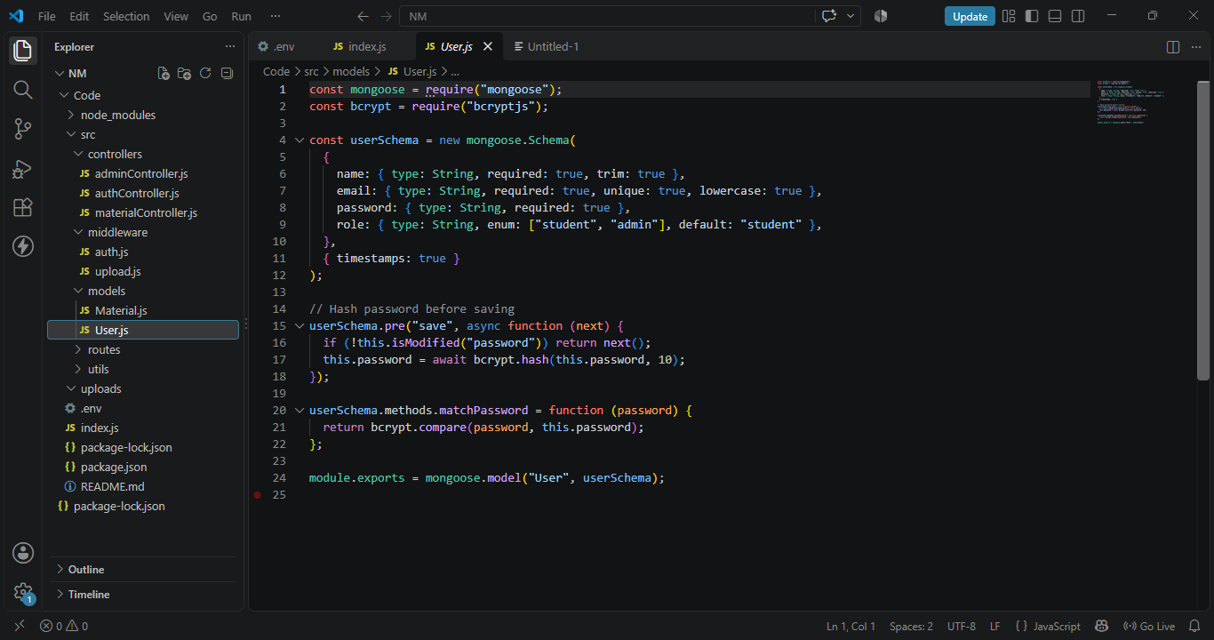

11. API Testing Using PostmanPostman is used to test and verify the backend APIs.
The major APIs tested include:
- User Registration
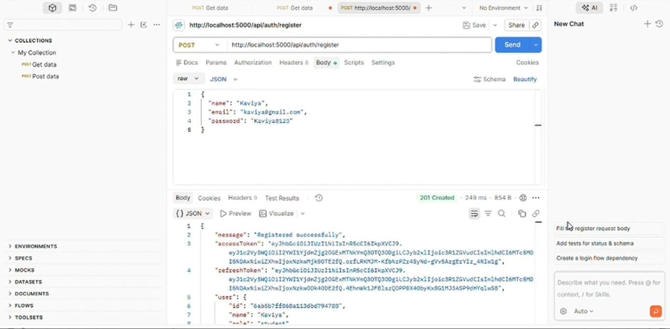

- User Login
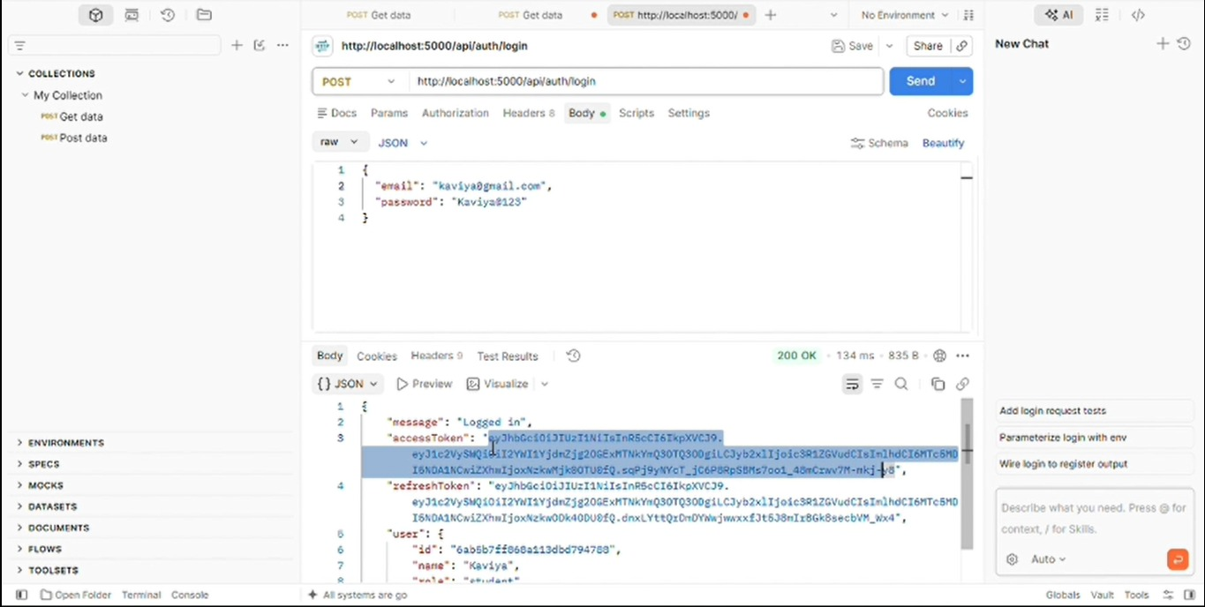
- Authentication
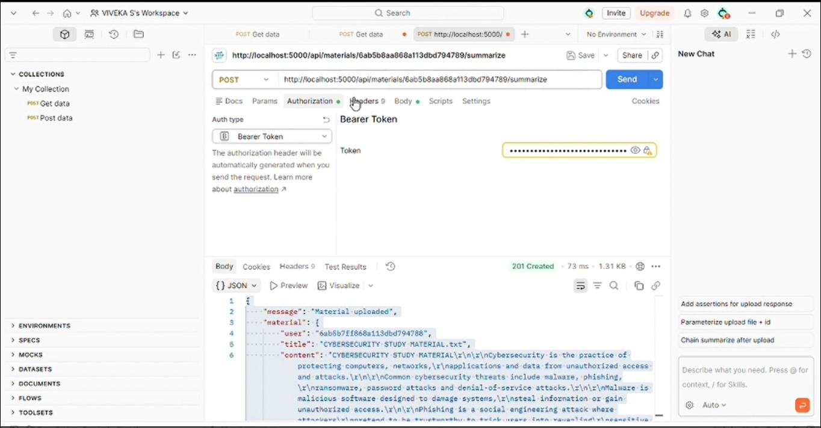

- Study Material & Upload
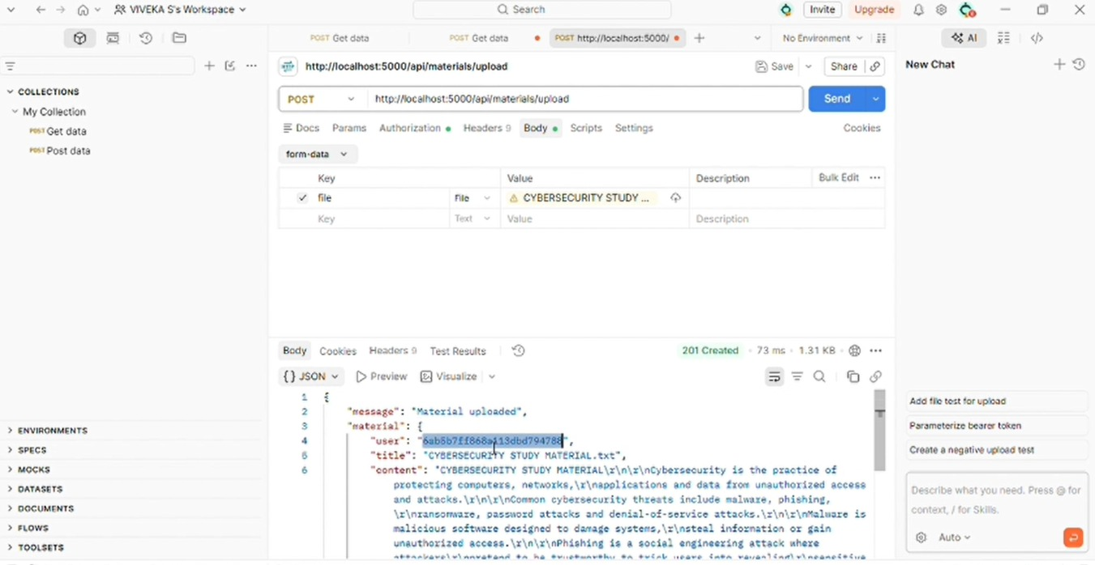

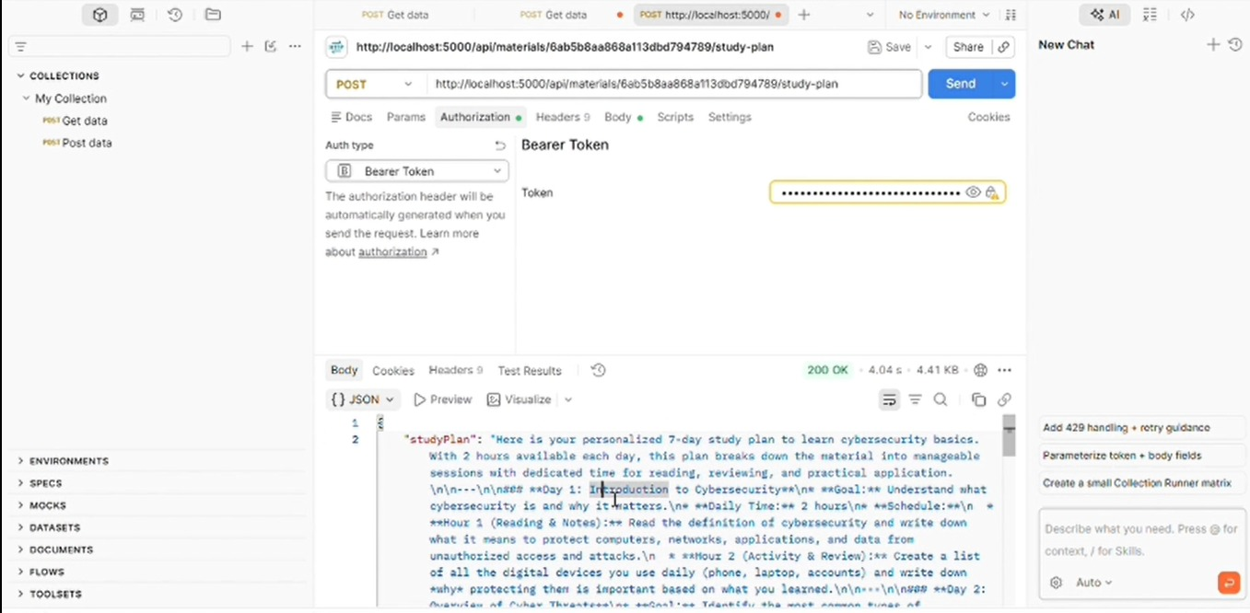

- Summary Generation
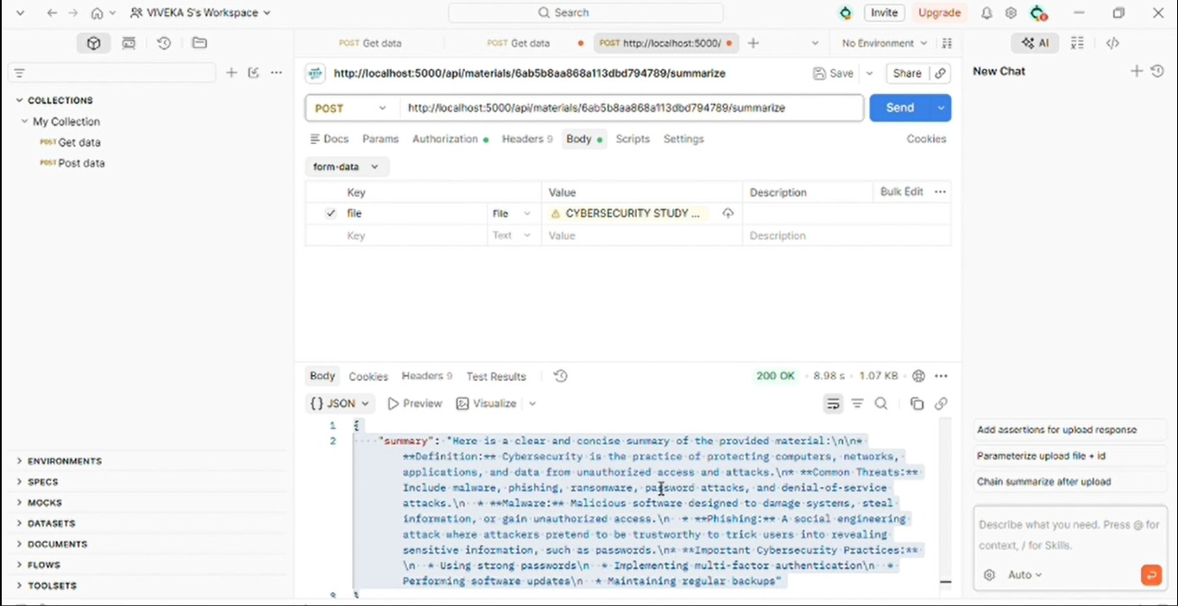

- Quiz Generation
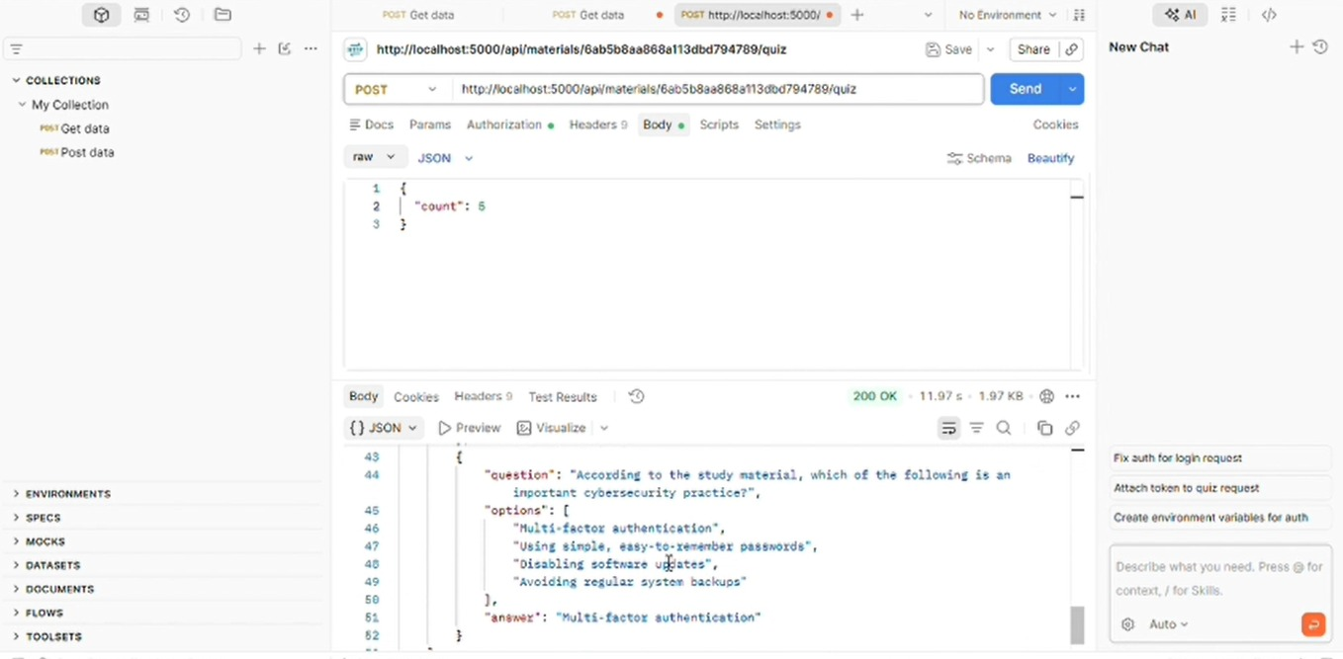

g.flash-card

h.delete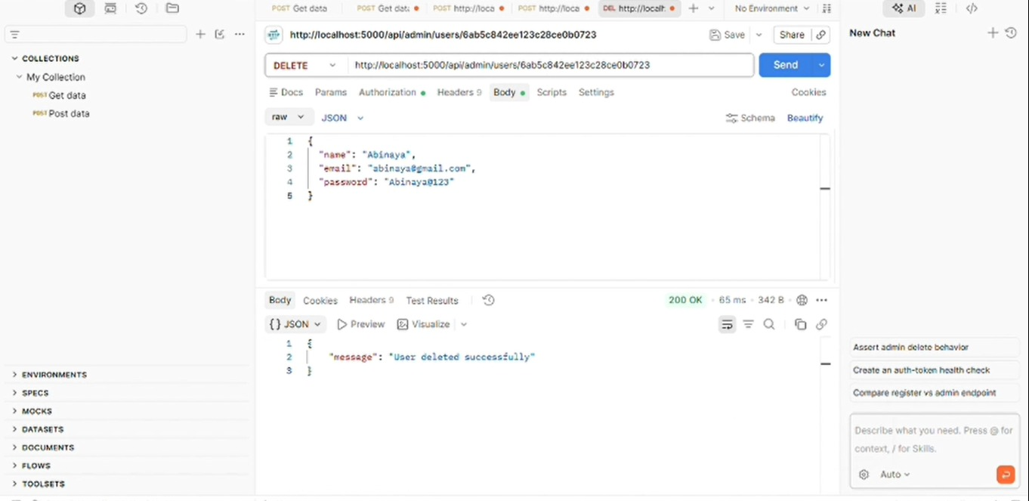

i.logout
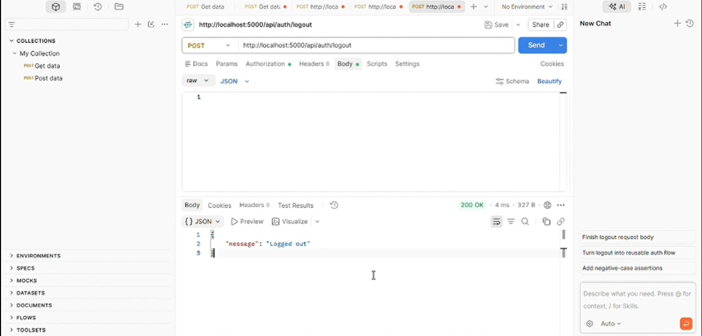
API testing is performed to verify request handling, response data, authentication, authorization, and error handling.

12.Database Management
MongoDB is used as the primary database.
The database stores application-related information such as:
- User details
- User roles
- Authentication-related information
- Study material details
- Other application records
MongoDB provides a flexible document-based structure suitable for the backend application.
13. Security Features
The application includes several security mechanisms:
- Bcrypt password hashing
- JWT-based authentication
- Access and refresh tokens
- Protected API routes
- Role-based authorization
- Environment variables for sensitive configuration
- Input validation
- Error handling
14.Key Features
- Secure User Registration
- User Login
- JWT Authentication
- Study Material Upload
- AI-Based Summarization
- AI-Based Quiz Generation
- MongoDB Database
- Postman API Testing
- GitHub Version Control

15. API Workflow
The overall workflow of the application is:

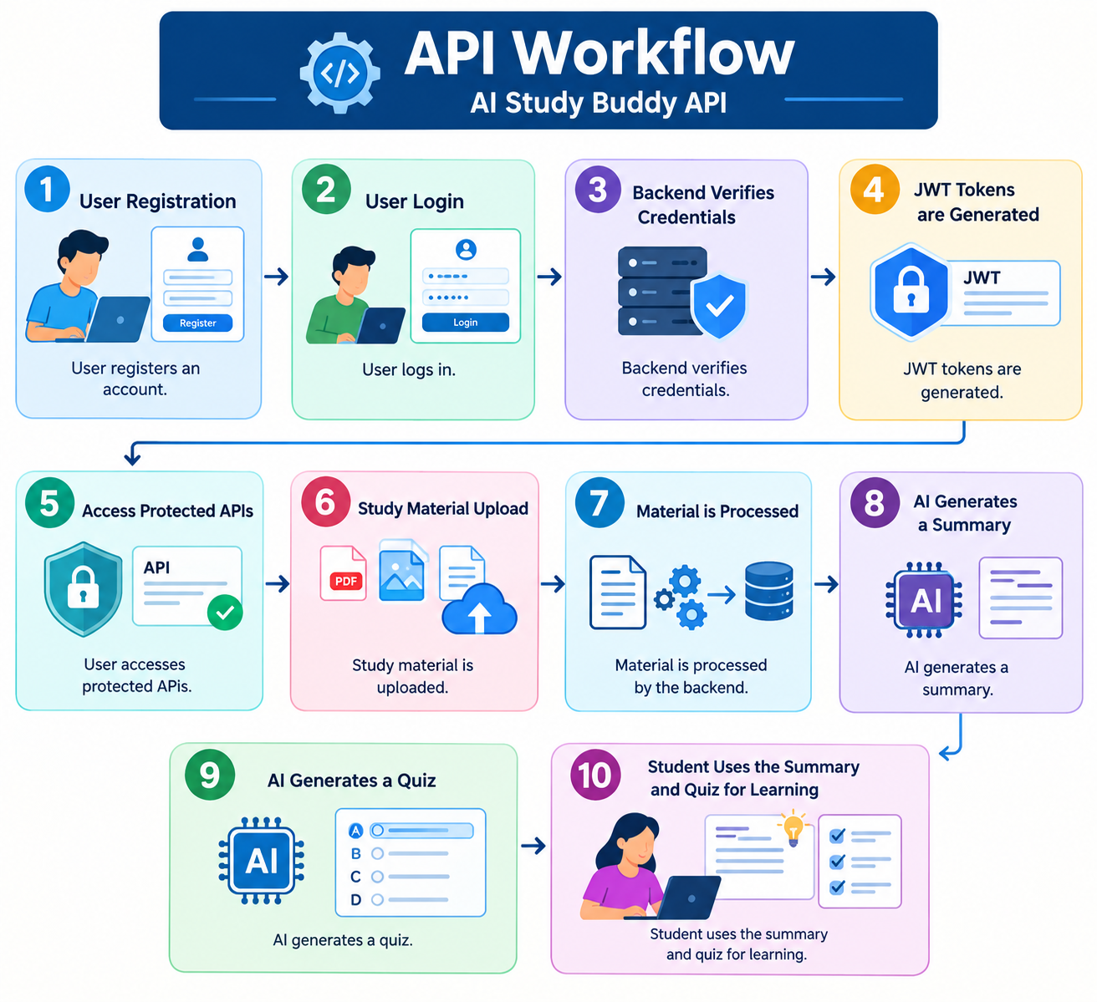

16. Results
The AI Study Buddy API successfully provides a backend platform for AI-assisted learning.
The system supports:
- User registration and login.
- Secure authentication and authorization.
- Study material upload.
- AI-based summary generation.
- Automatic quiz generation.
- Database management.
- API testing through Postman.
17. Future Enhancements
- Personalized learning recommendations.
- Student performance tracking.
- Progress dashboards.
- More document format support.
- Quiz difficulty levels.
- Personalized AI study assistance.
- Notifications and study reminders.
- Advanced learning analytics.
18. Conclusion
AI Study Buddy API is a secure and AI-powered backend system designed to support students in their learning process.
By combining Node.js, Express.js, MongoDB, JWT, Bcrypt, and Gemini AI, the system provides secure authentication, study material management, AI-based summarization, and automatic quiz generation.
The project demonstrates how Artificial Intelligence can be integrated with backend technologies to create an interactive and efficient learning support system.

